SFDCLogin_SFDC_Login_Demo_Instance1_09-Dec-2017_02-42-13_PM_Validation.png

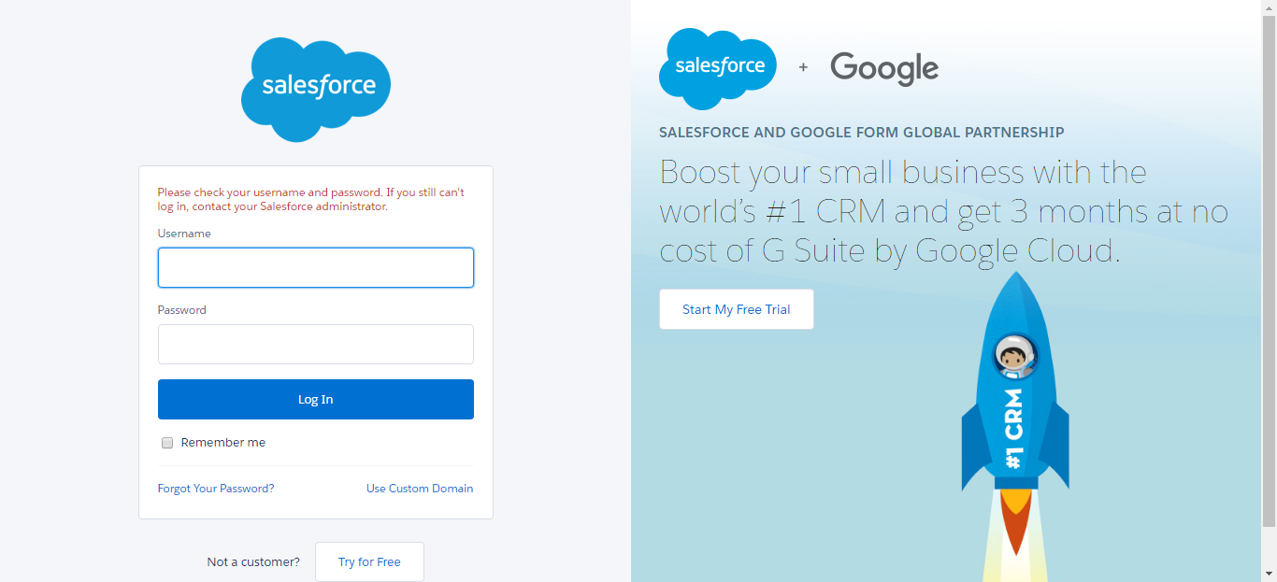

SFDCLogin_SFDC_Login_Demo_Instance1_09-Dec-2017_02-42-21_PM_Validation.png

